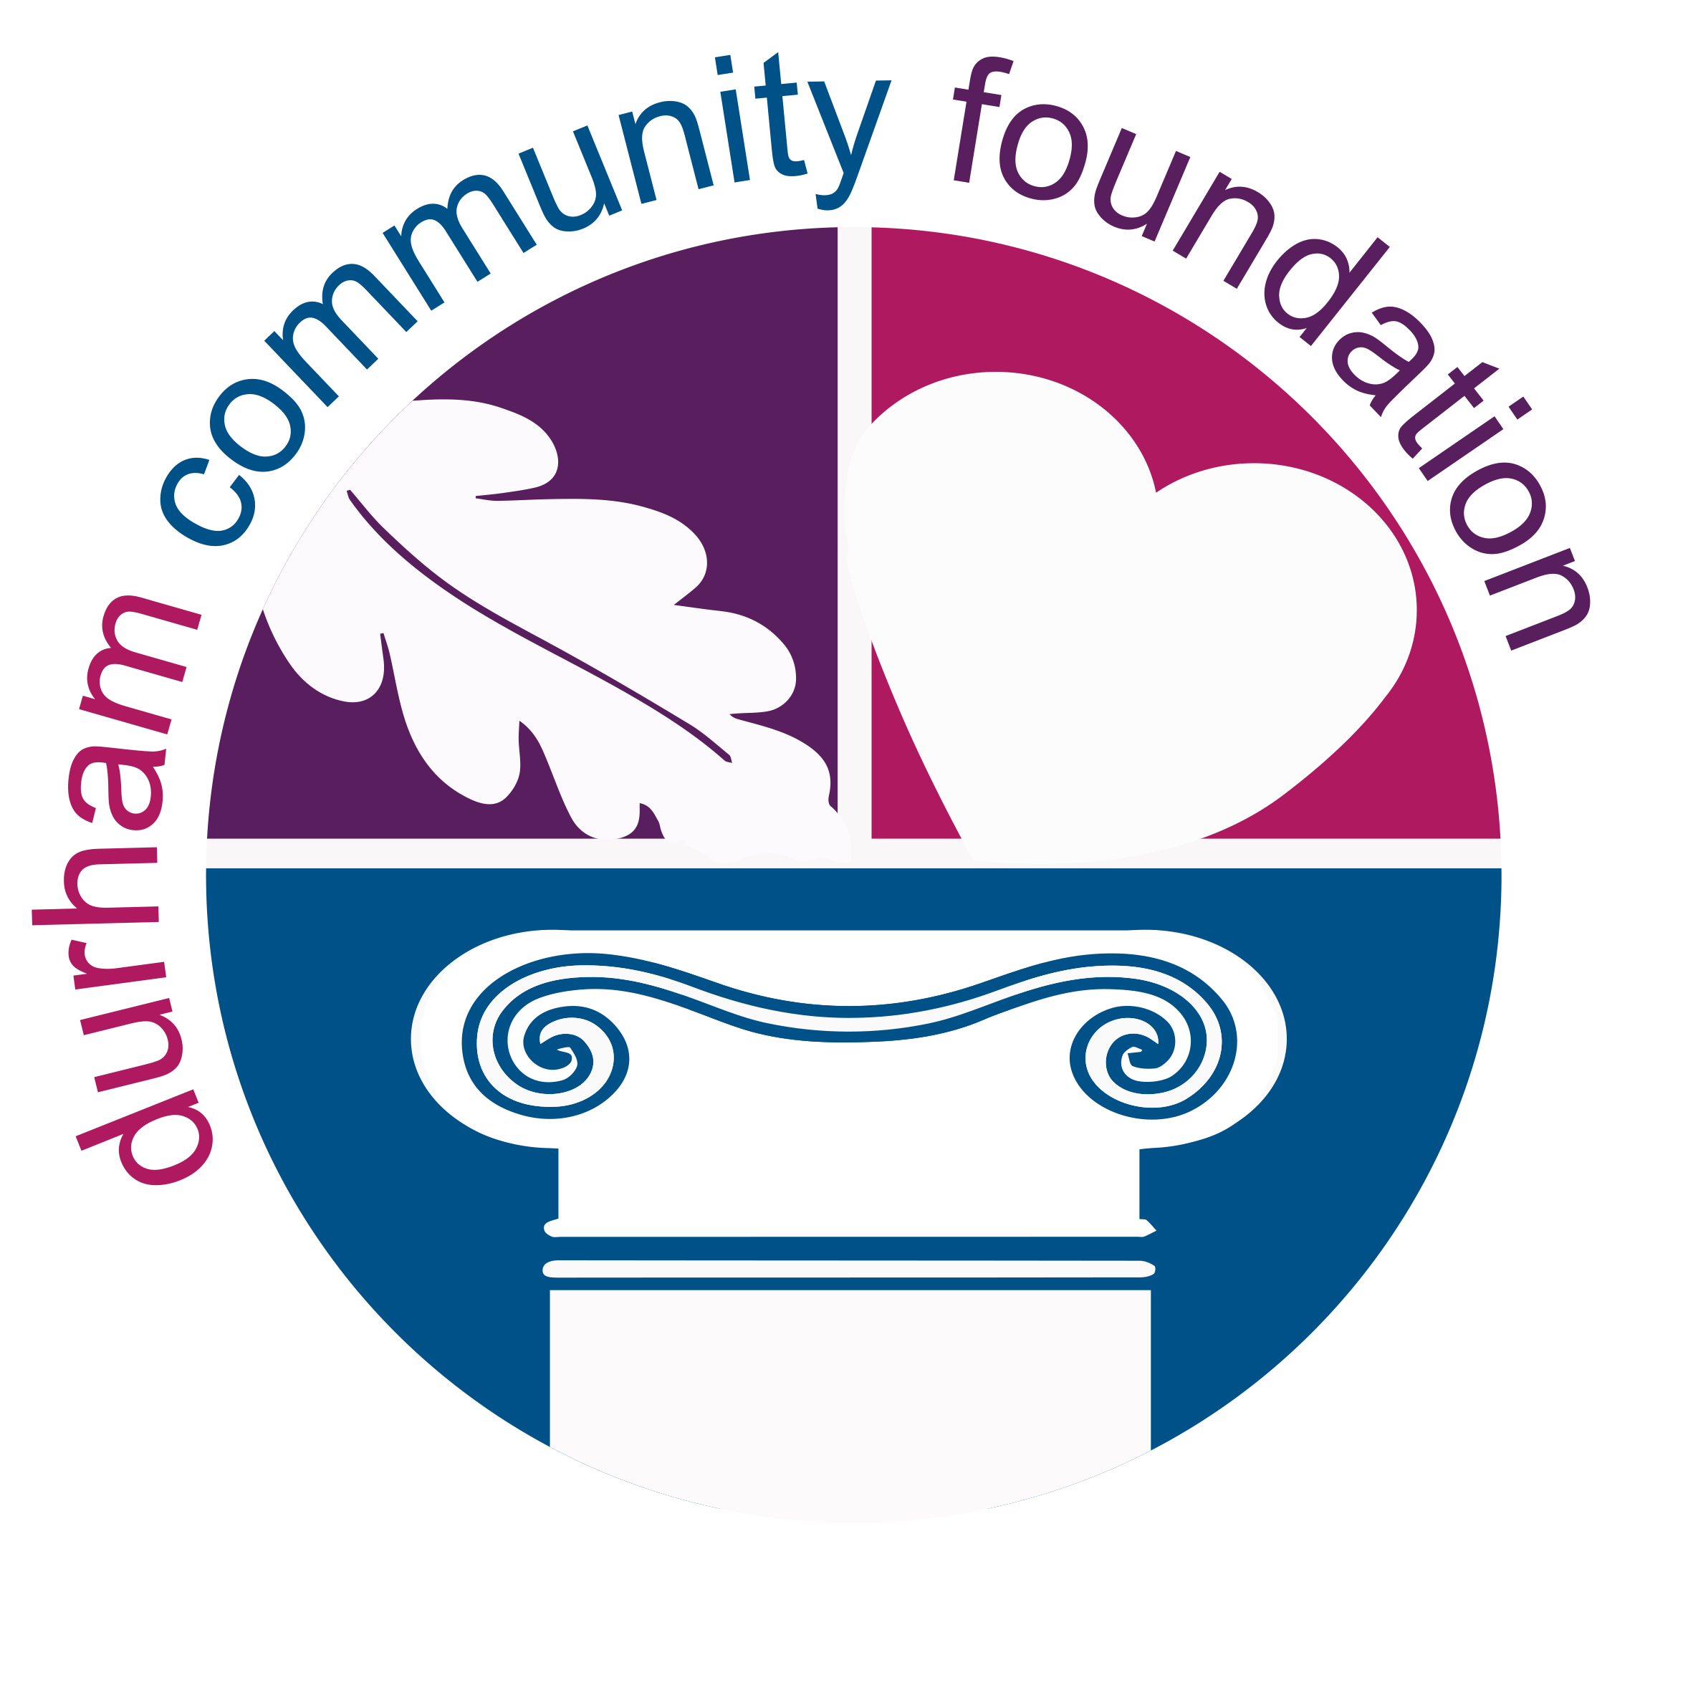
The Mildred and Jeremiah Coughlan Scholarship

HISTORY

The Mildred and Jeremiah Coughlan Scholarship was first established in 1997, by local businessman Jerry Coughlan in memory of his parents Mildred and Jeremiah Coughlan.

In 1958 Coughlan Homes founder, Jerry Coughlan, received a small loan from his mother to launch a real estate development company. He aptly named it Coughlan Homes. Jerry built his first home in East York. He focused on moving east as the GTA rapidly expanded, and he recognized great potential. Jerry began developing in Scarborough, then added Pickering, and soon after, Ajax.

From the beginning of his career, Jerry established a reputation for building a quality product and fostering a corporate culture that focused on customer service and a keen attention to detail.

Honouring the legacy of their Father, the children of Jerry established The Mildred and Jeremiah Coughlan Scholarship endowment fund at Durham Community Foundation in 2017.

PURPOSE

Available to a student graduating from a high school in Ajax or Pickering and entering their first year of a post-secondary education program, this $3,000 scholarship supports students who require financial assistance to pursue their education goals and considers strong academic achievement, engagement in extra-curricular activities and active involvement in the community.

REQUIREMENTS

To be considered applicants must include the following along with a completed application form:
- most recent grade transcripts
- letter of recommendation by the applicant’s guidance counsellor
- short essay

Note: If qualifications are successfully met, two $3,000 scholarships will be awarded in summer 2022.

APPLICATION FORM

PERSONAL INFORMATION
Name

Home Address
Telephone

Email

EDUCATION INFORMATION
High School

Anticipated Graduation Date

Plans for Post-Secondary
Education in Fall 2022

SHARE WITH US
Career Goals
Volunteer Work
Extra-Curricular Activities
Special Interests

ESSAY
The Coughlan Family is recognized as both community builders and philanthropists.
Please include on a separate page, in 500 words or less, why you feel you should receive The Mildred and Jeremiah Coughlan Scholarship. (Must be typed; double-spaced; maximum of one page. Applications not following these requirements will not be considered.)

SUBMISSION
By providing us with your signature below you declare that all information on this application is accurate and you are in need of financial assistance in order to pursue your post-secondary education goals.

Signature Date

Please email the completed application form, essay, a recommendation letter from your guidance counsellor and transcript of your most recent grades to:

Vivian Curl, Executive Director, Durham Community Foundation
Email: Vivian@DurhamCommunityFoundation.ca
NOTE: Applications must be received no later than April 30, 2022.

Additional Details:
- Award winners will be notified in May 2022.
- Scholarship funds will be issued by Durham Community Foundation directly to the post-secondary institution which the successful recipient is enrolled.
Note: Immediate relatives of the Coughlan family, or relatives of members of the Selection Committee for that particular year, are not eligible to apply.

